CPE403 – Advanced Embedded Systems

# Design Assignment 4

DO NOT REMOVE THIS PAGE DURING SUBMISSION:

Name: Rishawn Peppers Johnson

Email: peppersj@unlv.nevada.edu

Github Repository link (root): <https://github.com/PeppersJ/v4e0nk_i3>

Youtube Playlist link (root): <https://drive.google.com/drive/u/2/folders/1fJ029-AAWjTnN-QrRqNLd0iLwKGm6A08>

**Follow the submission guideline to be awarded points for this Assignment.**

Submit the following for all Assignments:

1. In the document, for each task submit the modified or included code (from the base code) with highlights and justifications of the modifications. Also include the comments. If no base code is provided, submit the base code for the first task only.
2. Create a private Github repository with a random name (no CPE/403, Lastname, Firstname). Place all labs under the root folder TIVAC, sub-folder named Assignment1, with one document and one video link file for each lab, place modified c files named as asng_taskxx.c.
3. If multiple c files or other libraries are used, create a folder asng1_t01 and place these files inside the folder.
4. The folder should have a) Word document (see template), b) source code file(s) with startup_ccs.c and other include files, c) text file with youtube video links (see template).
5. Submit the doc file in canvas before the due date. The root folder of the github assignment directory should have the documentation and the text file with youtube video links.
6. Organize your youtube videos as playlist under the name “cpe403”. The playlist should have the video sequence arranged as submission or due dates.
7. Only submit pdf documents. Do not forget to upload this document in the github repository and in the canvas submission portal.
8. Code for Tasks. for each task submit the modified or included code (from the base code) with highlights and justifications of the modifications. Also include the comments. If no base code is provided, submit the base code for the first task only. Use separate page for each task.

/* Modified By: Rishawn Peppers Johnson

* Date Created: 13 November 2020

* Device: CC1352R1 & MKII

* CpE 403 Assignment 04

*

* Purpose: Interface the TivaC123GH6PM with the Educational BoosterPack MKII to

* read the MKII's vertical joystick value using TivaC's ADC, display the ADC

* value to terminal through UART, constatly update the PWM duty cycle routed

* to an LED.

*

* Inputs: MKII horizontal joystick

* Outputs: UART to terminal ADC value

* PWM value to LED

* */

/*

* Copyright (c) 2015-2019, Texas Instruments Incorporated

* All rights reserved.

*

* Redistribution and use in source and binary forms, with or without

* modification, are permitted provided that the following conditions

* are met:

*

* * Redistributions of source code must retain the above copyright

* notice, this list of conditions and the following disclaimer.

*

* * Redistributions in binary form must reproduce the above copyright

* notice, this list of conditions and the following disclaimer in the

* documentation and/or other materials provided with the distribution.

*

* * Neither the name of Texas Instruments Incorporated nor the names of

* its contributors may be used to endorse or promote products derived

* from this software without specific prior written permission.

*

* THIS SOFTWARE IS PROVIDED BY THE COPYRIGHT HOLDERS AND CONTRIBUTORS "AS IS"

* AND ANY EXPRESS OR IMPLIED WARRANTIES, INCLUDING, BUT NOT LIMITED TO,

* THE IMPLIED WARRANTIES OF MERCHANTABILITY AND FITNESS FOR A PARTICULAR

* PURPOSE ARE DISCLAIMED. IN NO EVENT SHALL THE COPYRIGHT OWNER OR

* CONTRIBUTORS BE LIABLE FOR ANY DIRECT, INDIRECT, INCIDENTAL, SPECIAL,

* EXEMPLARY, OR CONSEQUENTIAL DAMAGES (INCLUDING, BUT NOT LIMITED TO,

* PROCUREMENT OF SUBSTITUTE GOODS OR SERVICES; LOSS OF USE, DATA, OR PROFITS;

* OR BUSINESS INTERRUPTION) HOWEVER CAUSED AND ON ANY THEORY OF LIABILITY,

* WHETHER IN CONTRACT, STRICT LIABILITY, OR TORT (INCLUDING NEGLIGENCE OR

* OTHERWISE) ARISING IN ANY WAY OUT OF THE USE OF THIS SOFTWARE,

* EVEN IF ADVISED OF THE POSSIBILITY OF SUCH DAMAGE.

*/

/*

* ======== hello.c ========

*/

**#include** <stdio.h> // Common C functions

/* XDC Module Headers */

**#include** <xdc/std.h>

**#include** <xdc/cfg/global.h>

**#include** <xdc/runtime/System.h>

/* BIOS Module Headers */

**#include** <ti/sysbios/BIOS.h>

**#include** <ti/sysbios/knl/Task.h>

**#include** <ti/sysbios/knl/Semaphore.h>

**#include** <ti/sysbios/knl/Clock.h>

/* Driver Header files */

**#include** <ti/drivers/ADC.h>

**#include** <ti/drivers/UART.h>

**#include** <ti/drivers/GPIO.h>

**#include** <ti/drivers/PWM.h>

/* Board Header file */

**#include** <ti/drivers/Board.h>

/* Driver configuration */

**#include** "ti_drivers_config.h"

// Variables

uint16_t adcValue;

uint16_t count = 0; // 1ms timer interrupt count

// Prototypes

**void** **timer0Fxn**();

**void** **idleFxn**();

**void** **readADCFxn**();

**void** **displayUARTFxn**();

**void** **ledPWMFxn**();

**void** **hearbeatFxn**();

/*

* ======== main ========

*/

**int** **main**() {

/* Call driver init functions */

Board_init();

**GPIO_init**();

**UART_init**();

**PWM_init**();

**ADC_init**();

/* Configure the LED pin */

**GPIO_setConfig**(CONFIG_GPIO_LED_0, GPIO_CFG_OUT_STD | GPIO_CFG_OUT_LOW);

/* Turn on user LED */

**GPIO_write**(CONFIG_GPIO_LED_0, CONFIG_GPIO_LED_ON);

System_printf("Assignment 4\nUse the MKII's horizontal joy stick to adjust green LEDs PWM value");

// Kernal Start

BIOS_start();

**return**(0);

}

**void** **timer0Fxn**() {

// Triggered every 1ms

count++;

**if** (count == 5) // Run ADC

Semaphore_post(adc_sem);

**else** **if** (count == 10) // Display ADC value on UART

Semaphore_post(uart_sem);

**else** **if** (count == 15) { // Update PWM value

Semaphore_post(pwm_sem);

count = 0;

}

}

**void** **workLoopFxn**() {

// Main loop

Timer_start(timer0); // Start counting Timer

**while** (1) {}

}

**void** **readADCFxn**() {

// Read in AD0's (horizontal joy stick) value

// Create and initialize joy stick peripheral

ADC_Handle adc;

ADC_Params params;

**ADC_Params_init**(&params);

adc = **ADC_open**(CONFIG_ADC_0, &params);

**while**(1) { // Dosen't check if conversion was successful

**ADC_convert**(adc, &adcValue);

Semaphore_pend(adc_sem, BIOS_WAIT_FOREVER);

}

}

**void** **displayUARTFxn**() {

// Displays ADC value to terminal

**const** **char** prompt[] = "Console Entry:\r\n";

UART_Handle uart;

UART_Params uartParams;

/* Create a UART with data processing off. */

**UART_Params_init**(&uartParams);

uartParams.writeDataMode = *UART_DATA_BINARY*;

uartParams.readDataMode = *UART_DATA_BINARY*;

uartParams.readReturnMode = *UART_RETURN_FULL*;

uartParams.baudRate = 115200;

uart = **UART_open**(CONFIG_UART_0, &uartParams);

**if** (uart == NULL) {

/* UART_open() failed */

**while** (1);

}

**UART_write**(uart, prompt, **sizeof**(prompt));

**char** adcValueStr[6]; // ADC value as C string

uint32_t clearCount = 0; // Count till clearing console

**while** (1) { // Infinitely display ADC value

**sprintf**(adcValueStr, "%d\r", adcValue); // Convert int to string

**UART_write**(uart, adcValueStr, **sizeof**(adcValueStr));

**if**(clearCount == 60) {

**UART_write**(uart, " \r", **sizeof**(adcValueStr)); // Clear old value

clearCount = 0;

}

clearCount++;

Semaphore_pend(uart_sem, BIOS_WAIT_FOREVER);

}

}

**void** **ledPWMFxn**() {

// Check if switch is pressed and update PWM duty cycle to LED

PWM_Handle pwm;

PWM_Params params;

uint16_t pwmPeriod = 3100; // Period and duty in microseconds

uint16_t duty = 0;

// Create and initialize PWM

**PWM_Params_init**(&params);

params.periodUnits = *PWM_PERIOD_US*;

params.periodValue = pwmPeriod;

params.dutyUnits = *PWM_DUTY_US*;

pwm = **PWM_open**(CONFIG_PWM_0, &params);

**PWM_start**(pwm);

**while** (1) {

duty = adcValue; // 32bit to 16bit

**PWM_setDuty**(pwm, duty);

Semaphore_pend(pwm_sem, BIOS_WAIT_FOREVER);

}

}

**void** **hearbeatFxn**() {

// Toggle Red LED every 1s

uint32_t time = 1000000/Clock_tickPeriod; // 1 second

**while** (1) {

Task_sleep(time);

**GPIO_toggle**(CONFIG_GPIO_LED_0);

}

}

1. Block diagram and/or Schematics showing the components, pins used, and interface.

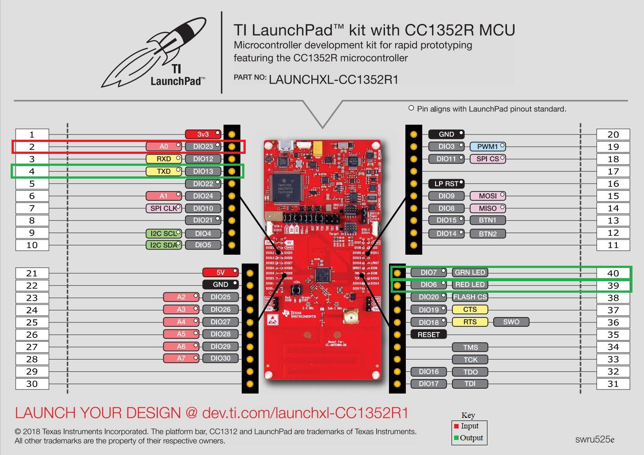

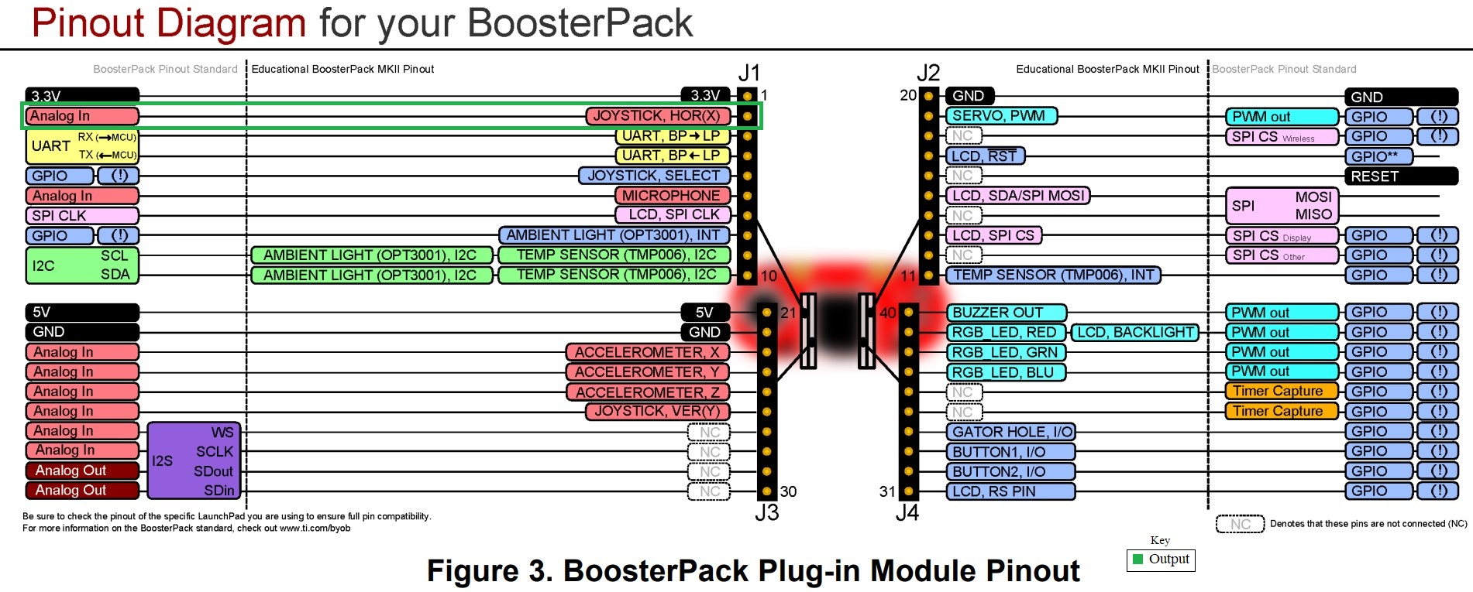

1. Screenshots of the IDE, physical setup, debugging process - Provide screenshot of successful compilation, screenshots of registers, variables, graphs, etc.

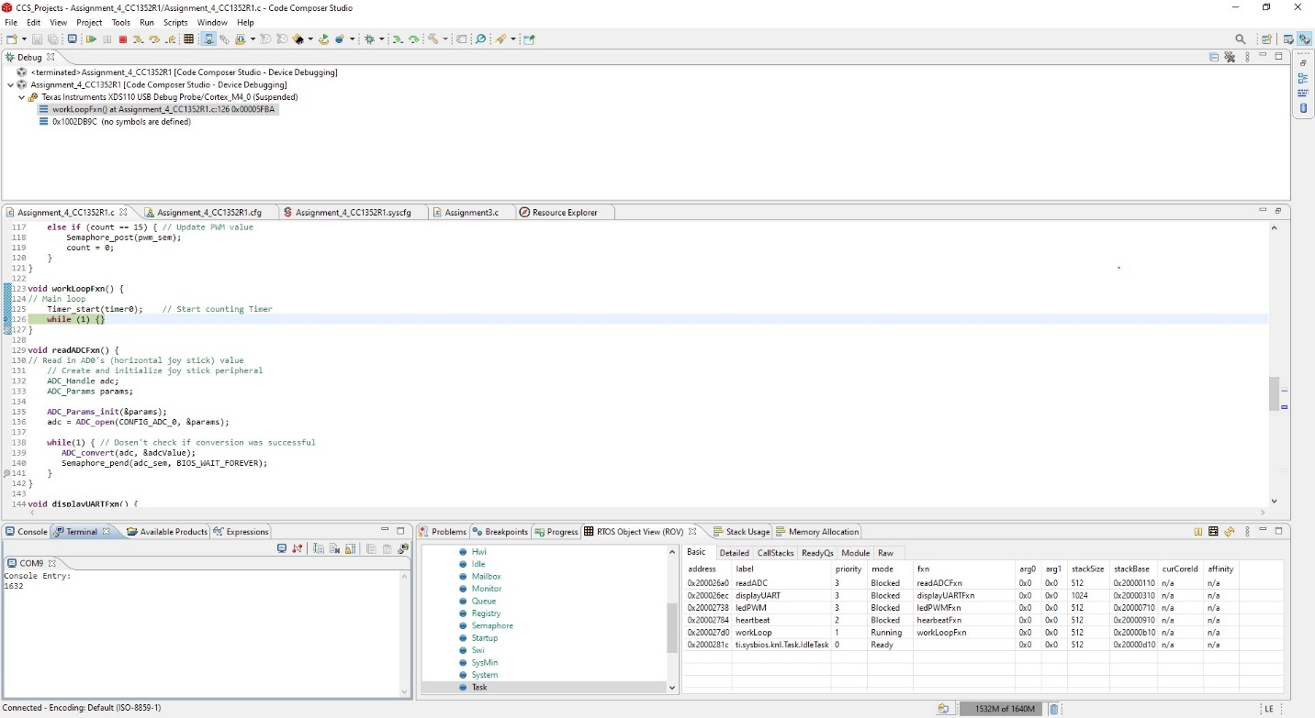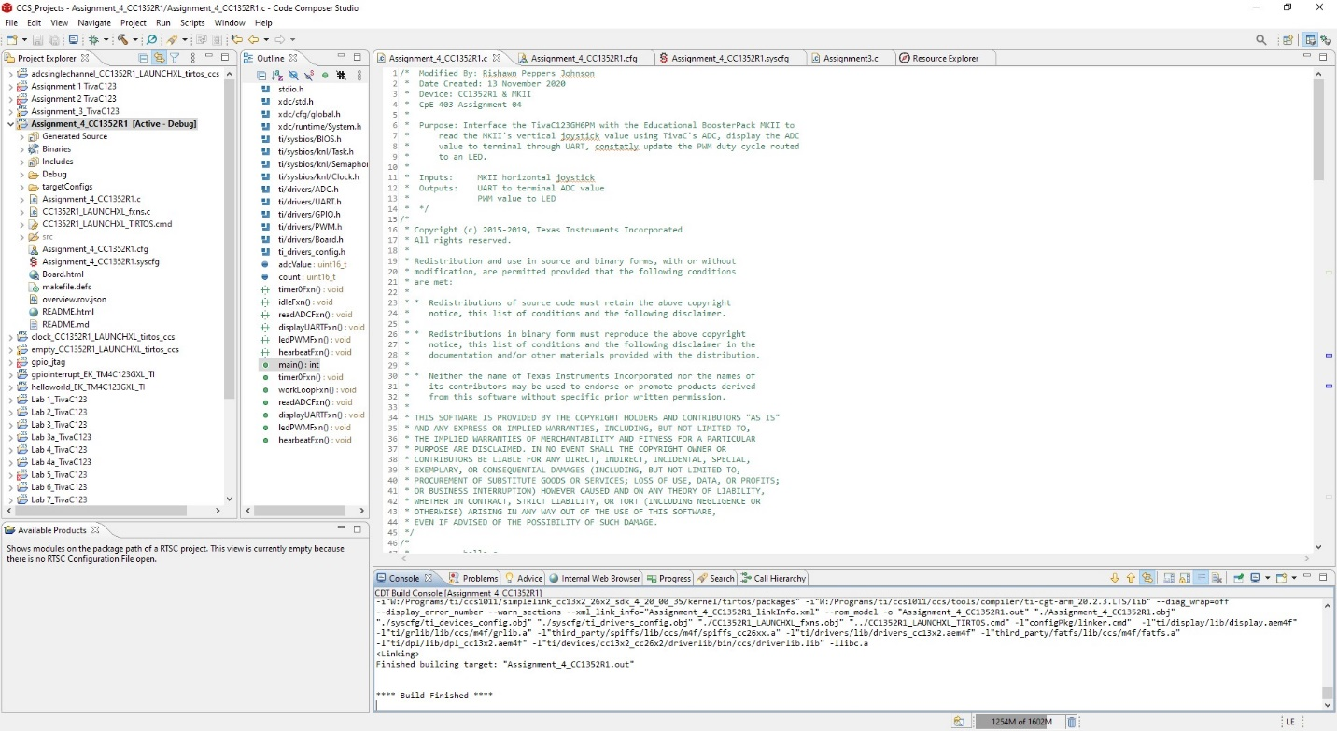

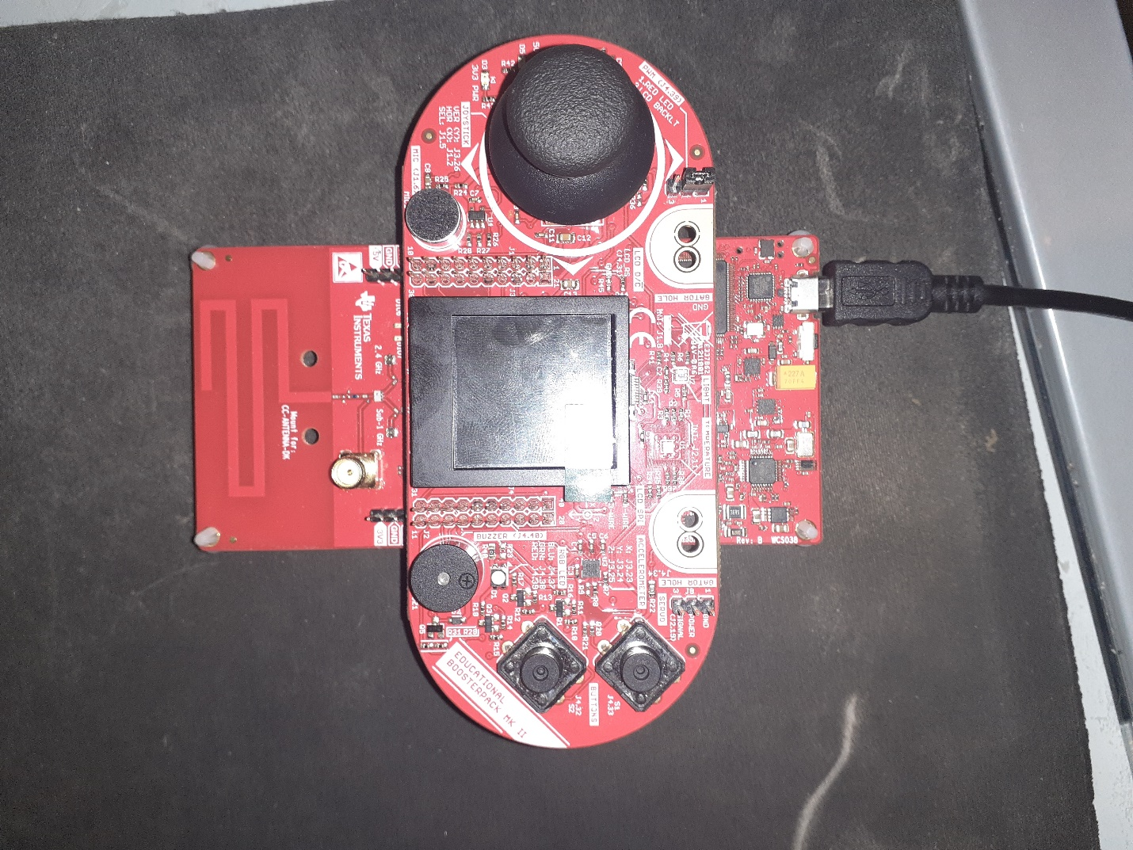

1. Declaration

I understand the Student Academic Misconduct Policy - http://studentconduct.unlv.edu/misconduct/policy.html

“This assignment submission is my own, original work”.

Rishawn Peppers Johnson